LAB # 15

Introduction to GitHub

OBJECTIVE
Performing commit, push, and pull operations from eclipse repository and analyzing version changes on Git repository.

Lab Task:
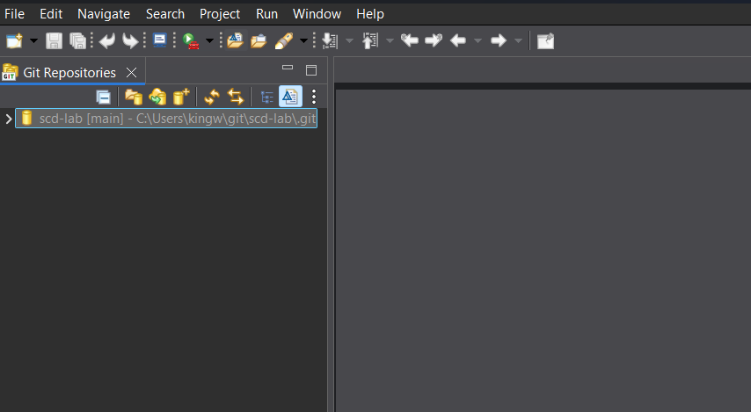
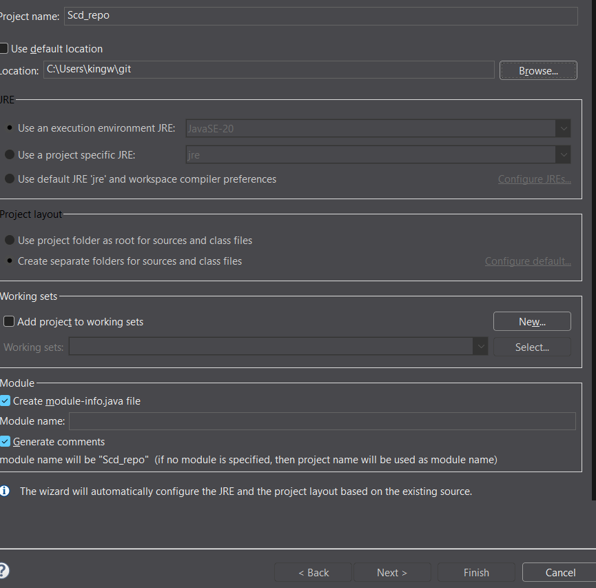
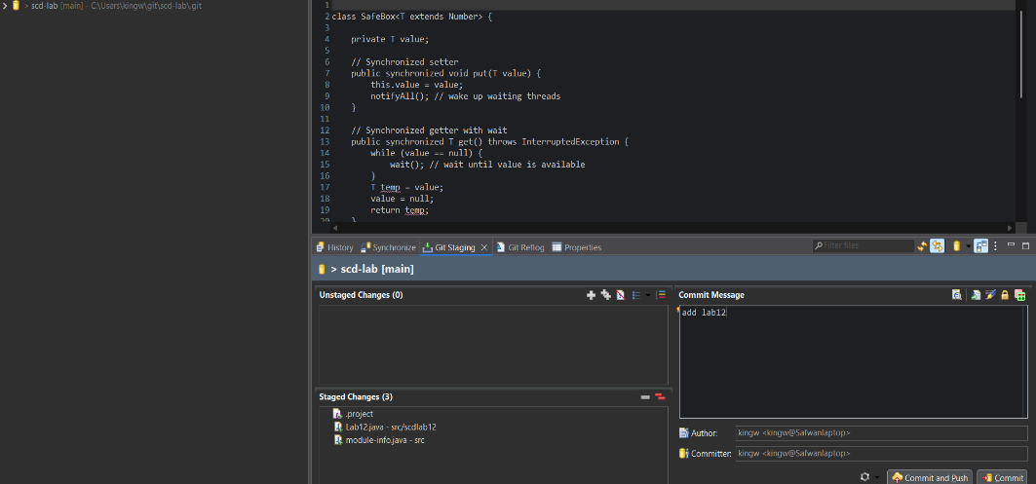

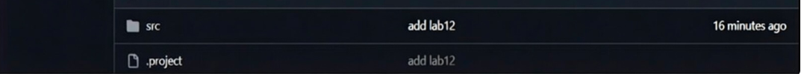
Github Screenshot:

